Lecture 4: Food policies
Food policies
- Food price dilemma and food policy definition
- Categories of policies
- Examples
- Sources of policy risk
- Sources of information about policies

Readings
- FEWS NET (2008) “Market Assessment and Analysis: Learners Notes. Lesson 3: Market Indicators: Annex 3: Policy impacts on markets and population” FAO. P. 24. http://www.fews.net/docs/Publications/Market%20Assessment%20and%20Analysis%20Training%20Module.pdf
- Dorosh, Paul A., 2001. “Trade Liberalization and National Food Security: Rice Trade between Bangladesh and India.” World Development 29 (4) pp. 673-689.
doi:10.1016/S0305-750X(00)00121-2
http://www.sciencedirect.com/science/article/pii/S0305750X00001212

Supplementary Readings
- Barrett, C.B., Bellemare, M. (2011) “Why price volatility doesn’t matter” Foreign Affairs. July 12. http://www.foreignaffairs.com/articles/67981/christopher-b-barrett-and-marc-f-bellemare/why-food-price-volatility-doesnt-matter
- Dorosh, P., Dradri S., Haggblade, S. (2009) “Regional trade, government policy and food security: Recent evidence from Zambia. Food Policy.” Food Policy 34: 350–366.
doi:10.1016/j.foodpol.2009.02.001
http://www.sciencedirect.com/science/article/pii/S0306919209000189
- Timmer, P. (2008) Causes of High Food Prices. Asian Development Bank.
http://www.adb.org/documents/Working-Papers/2008/Economics-WP128.pdf

Before we identify the commodities to examine, we examine supply responsiveness tools and approaches. Analysis of food aid policies, spatial and temporal price patterns, import parity prices, and food balance sheets provides an overall picture of traders’ ability to increase supply if demand increases due to cash or voucher transfers, whether prices are expected to increase, and where to find adequate supply for local or regional procurement.

A variety of external factors, such as policies, weather, infrastructure, crop diseases, fertilizer costs, can contribute to food price formation. In what follows, we focus on policies affecting food markets (i.e., behaviors of producers, consumers, and traders) at the international, regional, national and local levels.

Food price dilemma and food policy definition
Governments face what Timmer et al. (1983) refer to as the “food price dilemma.” Producers want higher food prices, while consumers want lower food prices. Governments seeking to accommodate both parties can try to narrow the gap between what producers earn and what consumers pay through two mechanisms. First, governments can seek to improve market efficiency, by reducing transportation and infrastructure costs, improving storage, or decreasing other transactions costs. Second, governments can use policy levers in an effort to change prices or supply and demand. Food policies influence trader, consumer, and producer decisions and behaviors. Because policies can shape market participants’ incentives, they may render some interventions less effective or more costly than others. Using policy instruments tends to be faster and governments may regularly change policies.

Policies can be formal (i.e., governmental rule or regulation) or informal (i.e., non-governmental authority’s rules or governmental official requesting bribes). Practices and policies can change both the absolute and relative pricing of food as well as the ability of food to flow within a country or across borders. Corruption and other informal influences on trading behavior should also be treated as (informal) policies, particularly if traders commonly face them.

Lastly, not all policies-on-the-books are implemented. Nor are all implemented policies enforced, or even enforceable. Policy analysis should incorporate the efficacy of a policy in accomplishing its goals. For example, draconian policies that are not implemented are of less concern than less dramatic policies that are regularly enforced. Policies that change frequently can be a source of price volatility, increasing risk for traders. Traders facing risky market environments and highly uncertain prices may be less responsive to increased demand.

How do food policy assessments help answer the relevant MIFIRA sub-questions?:
1c. How much additional food can traders supply at or near current costs?
Policies can affect food markets, transport capacity, imports, exports, demand, production and competitive behavior in markets.

2a. Where are viable prospective source markets?
Policies affecting food exports and imports will influence how quickly and cost-effectively food can arrive.

Categories of policies
The policies of interest are those intended to directly influence food prices, availability or access. Other, secondary policies may indirectly or unintentionally influence food price outcomes, but are not the subject of our analysis. FEWS-NET lists key policy parameters and their potential impacts on both markets and the population.
FEWS-NET Policy Impacts (2009, Lesson 3, p. 24) 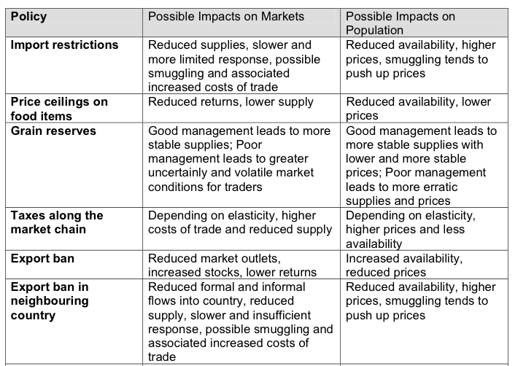
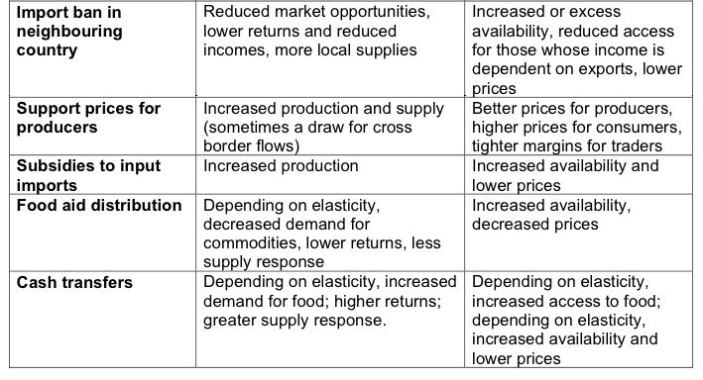
Other important food policies include non-tariff barriers and exchange rate policies.

Non-tariff barriers
Bottlenecks can be due to non-tariff barriers such as sanitary and phytosanitary standards, fumigation policies, certification requirements, or biosafety controls, which are especially important with respect to genetically modified foods. Non-tariff barriers and licensing can increase the costs of trade and discourage entry of additional traders, potentially limiting competition and driving up prices.

Exchange Rates:
A final, important source of food price variability are exchange rate policies. Are exchange rates fixed or floating? If the exchange rate for domestic currency is fixed, is it properly valued, overvalued or undervalued? Exchange rates with an overvalued currency will discourage exports and subsidize consumers while under-valued currency typically increases exports but at the cost of driving up domestic prices.

When currency depreciates or is devalued, imports become costlier and exports become cheaper. Therefore, following a devaluation, relatively more food may be exported than before a devaluation. When currency appreciates or is overvalued, imports are cheaper and exports are more costlier. An appreciated currency may lead to an increase in imported food, relative to before the appreciation.

According to the law of one price, exchange rates should equalize the prices of the same baskets of good across countries. However, as the Economist Magazine’s Big Mac Index shows, the cost of a Big Mac differs quite dramatically across countries.

Big Mac Index and Purchasing Power Parity

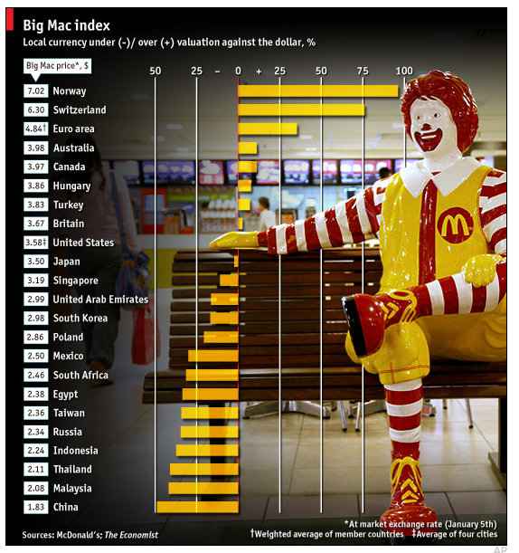
Source: Economist Magazine.

Examples:
Changing prices
Marketing boards continue to play major role in food and input markets. For example, marketing boards in sub-Saharan Africa shape maize prices; marketing boards handle 15-57% of maize in Kenya, 3-32% in Malawi, and 11-45% in Zambia (Jayne et al. 2005).

Price controls may increase demand, but if prices are set lower than producer costs, may decrease supply. Policies that decrease domestic prices relative to international prices may discourage production and may encourage (informal) exports. Policies that increase domestic prices relative to international prices may benefit producers but harm consumers while simultaneously making imports relatively expensive.

In the below example, a government imposes an import subsidy for consumers, which depresses the domestic price to below the world price and below the country’s self-sufficiency price. This lower price results in consumers demanding more product (Q4), while producers supply less (Q1).

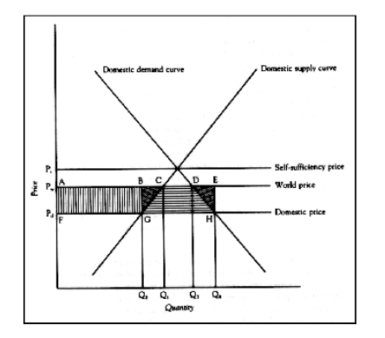
Source: Timmer et al. 1983, P. 192.

Supply shift
Exogenous factors, such as drought, can decrease supply. In the short-run, domestic supply of food is perfectly inelastic because there is a lag while additional food is grown. Government policies to open borders to trade will result in a lower price increase in food prices relative to a closed border.
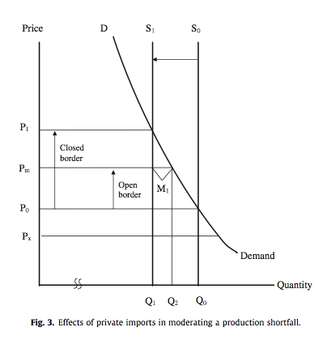
Source: Dorosh et al. 2009. P. 354

Role of the government of Bangladesh in stabilizing food supply in 1997/98
Poor harvests in 1997/98 increased rice prices, threatening food security for the ultra-poor. The Government of Bangladesh (GoB) responded to the production shortfall and the ensuing entitlement failures by altering major food policies. The government lacked stocks large enough to force prices down and faced significant delays in procuring rice from international markets, whether through government-directed purchases or food aid deliveries. When the domestic rice price rose to import parity, commercial imports into Bangladesh began to increase. To encourage these imports, the GoB removed tariffs on rice, making it duty free – and thereby both reducing trader out-of-pocket expenses and bureaucratic delays on cross-border deliveries – and raised the open market sales price of rice closer to the import parity price. The GoB also explained their policies to major rice traders, removing some of the uncertainty traders faced. Finally, the government did not instate anti-hoarding laws, which act as disincentives to both local traders and importers.

Several months later, during a massive flood, in late July and August 1998, these policies remained in effect and combined with food aid deliveries to keep rice prices relatively stable. Dorosh et al. (2004) write that immediately after the flood, household access to food was constrained by both availability of food in local markets and by limited purchasing power. Yet, “…by late September in most of the country poor households had access to well-supplied markets (and) their food consumption was constrained by a lack of purchasing power rather than by a lack of availability per se” (p.171). After this rapid-onset flood, the new government trade policies dramatically improved food availability. Drawn from Dorosh et al. (2004) Chapter 6: Policy Response to Production shocks: the 1997/98 Aman shortfall and the 1998 flood” in Dorosh et al. ed. The 1998 Floods and Beyond.

Government responses to rising food prices in COMESA and ASARECA countries, 2008
Governments commonly rely on policies to respond to food prices. The chart below traces how governments in COMESA and ASARECA responded to the food price crisis of 2007-2008.

 | Number of countries
Reduce taxes on food grains (+ +) | 7
Price controls/ consumer subsidies (- +) | 4
Fuel subsidies (+ -) | 1
Increase supply using food grain stocks (+ -) | 4
Increase supply via imports (+ +) | 2
Export restrictions (- -) | 4
Cash transfer (+ +) | 4
Food for work (+ +) | 4
Food ration/ stamp (+ -) | 4
School feeding (+ +) | 5

(+ + ) Consistent with long run policies to improve food security
( + - ) Some concerns for food security; ( - + ) Likely to hinder food security
( - - ) Highly likely to hinder food security

Source: World Bank, 2008 from “Improving the Performance of Staple Markets to Exploit the Productive Potential of Smallholder Agriculture” T. S. Jayne, A. Chapoto, and B. Shiferaw.

Sources of policy risk
Intervening in food markets is difficult. The outcomes of the above policies depend on the policy making authority’s enforcement capacity. To assess the sources of policy risk for traders consider:
- Does the government / local authority frequently change its food and trade policies?
- Is there speculation about significant policy change (i.e., policy risk to traders)?
- Does the policy-making authority provide adequate warning before policy changes are announced?
- Are policies generally implemented, and if so, are they enforced evenly across populations and regions?
- Has popular protest changed policy-implementation?
- Is corruption pervasive?

The more accountable, stable, and transparent the policy making authority is, the less policy risk for traders. If policy authorities frequently change policies unannounced, traders and producers may be reluctant to take on additional trading risk. Policies that increase price volatility are particularly damaging for food markets. In fact, sharply fluctuating prices suggest weak underlying food storage and marketing systems and can be a proxy indicator of food insecurity (Timmer 1989; Barrett 2002). While higher prices harm access and lower prices hinder availability, volatile prices can cause economy-wide disincentives. The welfare effects of price volatility are complex, but generally, price volatility harms net producers but it has ambiguous effects on net consumers.

Furthermore, a host of mutually inconsistent policies may be implemented and these policies not be aligned, meaning that one policy has an effect countervailed by another policy. Or, the short-run intentions of a policy may adversely affect longer-term policy goals.

Formal policies may not be enforced. Or, policies may be enforced for some market actors but not others. Ultimately, the true effect of each policy on food markets will vary across contexts depending on policy implementation, and depending on how individuals and institutions respond to these policies.

  - Trade policy outcomes depend on number of factors aside from policy design:
    - Implementation, institutional strength, enforcement
    - Transparency and responsiveness of policymakers
    - Stability / fickleness of policy regimes
  - Traders face policy risk:
    - Lack of transparency
    - Lack of predictability
    - Variable enforcement

Sources of information about likely effects of policy changes:
- Secondary sources of information on previous and current governmental policies can be found on government websites and in IMF and World Bank reports (e.g., the annual Cost of Doing Business report). Analysis of the effect of these policies may also be found in academic and gray literature.
- Once the relevant policies have been identified, discussions with traders will help reveal whether these policies create constraints or generate risk for traders.
- Key informant interviews with government officials, local NGOs, bankers, transporters, etc. can also provide valuable information.
  - Topics such as informal policies or sources of policy risk will be best answered by traders or key informants with knowledge of market actors.
  - See K. Kumar (1989). Conducting key informant interviews in developing countries (Washington, D.C.: USAID) for good guidelines on key interviewing techniques.

